



**BSLMC Application for Administrative**

**Review of Research**

**Department Reviewer/Approver Instructions**

Version 1.0

Office of Clinical Research

**Table of Contents**

**Definitions** 3

**Email to Department Reviewer/Approver** 4

**Logging into BSLMC Administrative Application** 5

**Basic Layout and Navigation** 5

**Department Review and Approval/Deferral** 7

**Institutional Approval or Deferral** 8

# **Definitions**

Enterprise Computing Account (ECA) – Access to the application requires a BCM ECA. This is also known as your Baylor email username. If you do not have an ECA, please contact the IT Service Center at 713-798-8737 or <https://sso.bcm.edu>.

Reviewer/Approver – There could be one more persons assigned as reviewer and/or approver for each hospital clinical area that plans to be used for the research study. This person(s) would receive the emails that there is an application that needs to be reviewed for their department for approval.

Principal Investigator (PI) – The person(s) in charge of a clinical trial or a scientific research grant. The principal investigator prepares and carries out the clinical trial protocol (plan for the study) or research paid for by the grant. The principal investigator also analyzes the data and reports the results of the trial or grant research.

Review Team – Review team or Administrative Review Team is the staff in the Office of Clinical Research that will review application for completeness and seek all necessary approvals from Baylor St. Luke’s Medical Center. Review team will be the primary contacts for any questions during the review.

Study Team – This consists of the PI and any of his staff working on the study.

Defer - Deferral of a study does not disapprove it, unless you enter a comment that you wish to disapprove it and reason. When a deferral is sent, the review team will let the study team know what questions or concerns the department or area may have to try to resolve them. If the issue is resolved, the department/area will be sent another email to re-review the study to either Approve or Defer again.

Approve – There are no concerns that need to be addressed and the department/area approves the study to be done.

Institutional Approval – BSLMC administrative approval from institutional official over research. Final approval before study can start at BSLMC.

# **Email to Department Reviewer/Approver**

All department reviewers and/or approvers will be sent an email for hospital areas/departments identified on the application for administrative review as needed for the study. The review team will enter a comment relevant to each department on what will be done in that area/department. The department reviewer/approver will click on the link to the BSLMC Administrative Application System and login with their assigned ECA.

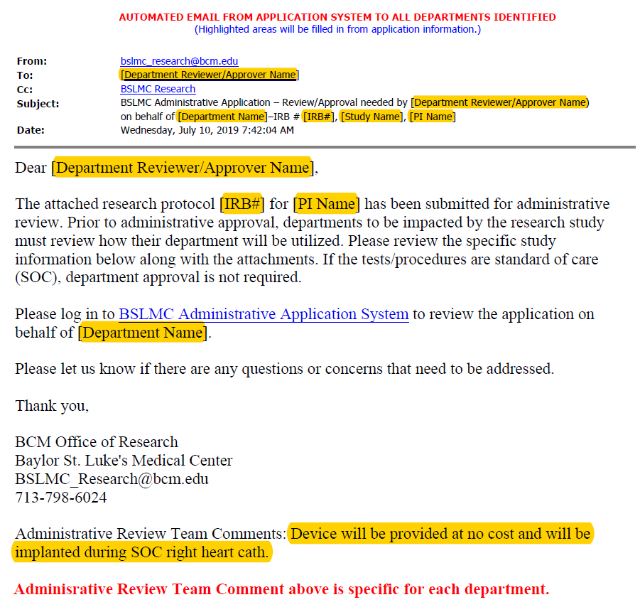

# **Logging into BSLMC Administrative Application**

Log in using your username and password. If you do not have a Baylor ECA, you can submit a request from BCM IT service portal (<https://sso.bcm.edu>) by entering a ticket.

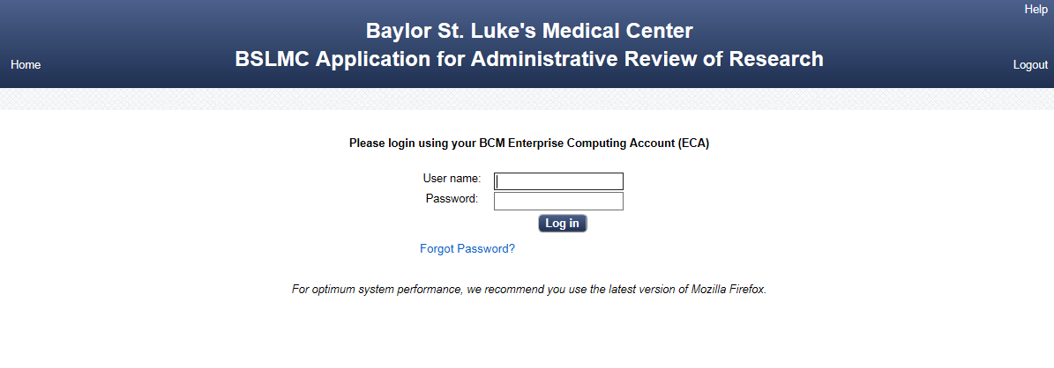

# **Basic Layout and Navigation**

Home – takes you to the Welcome Screen.

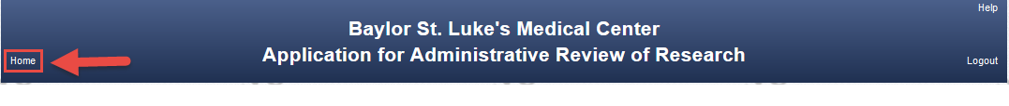

Help – pop-up screen with contact information.

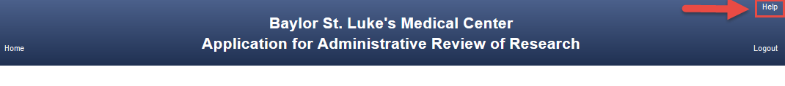

Logout – logs out of system, user name and password are required to re-enter system.



Menu – allows reviewer/approver to see any other applications pending approval and applications that have been completed.

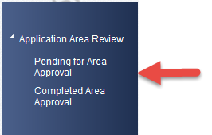

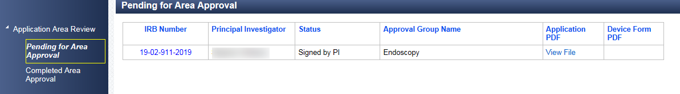

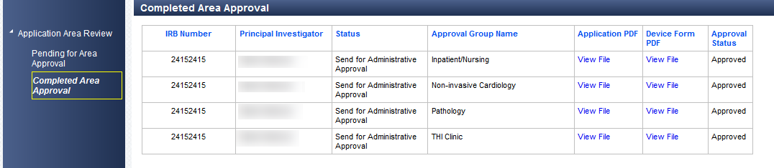

Do not use the browser’s back button. Use the menu in the system to navigate between pending and completed approvals.

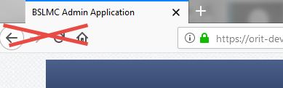

# **Department Review and Approval/Deferral**

Once the reviewer/approver logs into the system, the following screen will come up. Here you can use the menu to go to pending requests to see previously completed requests. You can also click on the Back to Pending Approval List to select the study you want to review if there are multiple. To see the full application for administrative review and study documents that are attached (i.e., protocol, consent, schedule of events, etc.), click on View Application. The comments box gives you information entered by the review team that may be specific to your department/area. To complete the process, you can enter a reply comment to the review team or comment to be shared with the study team and either click Approve or Defer.

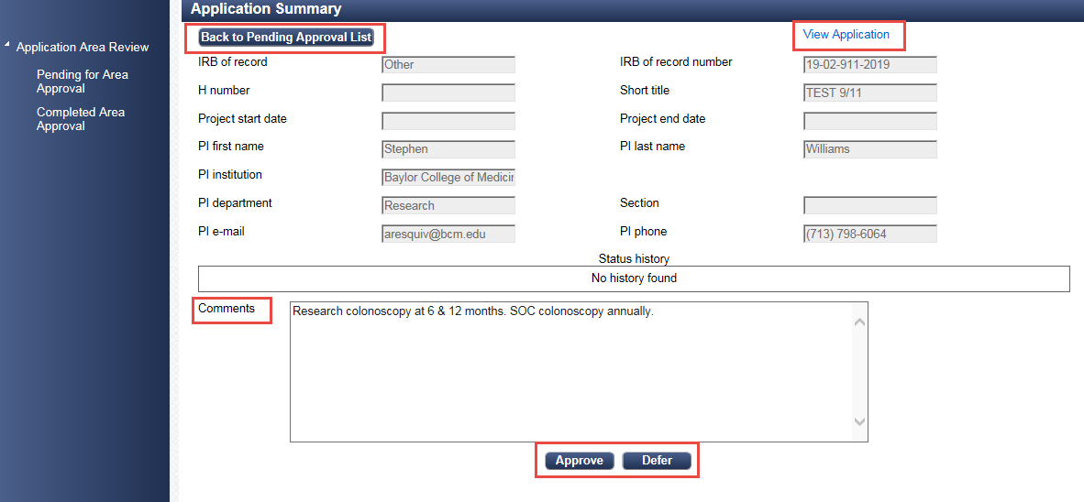



Once you click on Approve or Defer, an email is sent back to the review team informing them of the department approval or deferral.

You may contact the Office of Clinical Research for any questions at [BSLMC_research@bcm.edu](mailto:BSLMC_research@bcm.edu) or 713-798-6024.

# **Institutional Approval or Deferral**

If the study is approved, an email is sent to the department/area reviewer/approver informing them of the approval.

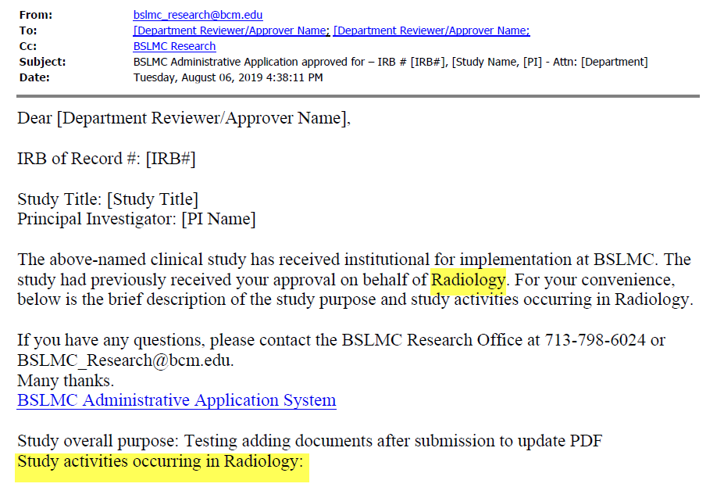

If study is deferred or not approved, then an email is sent the department/area reviewer/approver informing them of the deferral.

