



**BSLMC Application for Administrative**

**Review of Research**

**Institutional Reviewer/Approver Instructions**

Version 1.0

Office of Clinical Research

**Table of Contents**

**Definitions** 3

**Email to Institutional Reviewer/Approver** 4

**Logging into BSLMC Administrative Application** 5

**Institutional Approver Review, Approval or Deferral** 5

# **Definitions**

Enterprise Computing Account (ECA) – Access to the application requires a BCM ECA. This is also known as your Baylor email username. If you do not have an ECA, please contact the IT Service Center at 713-798-8737 or <https://sso.bcm.edu>.

Submitter – Person that completes the investigational device assessment form and/or application for BSLMC administrative approval for submission to the PI. This can be a regulatory person, administrative person, coordinator, or anyone working on the study with knowledge about the research study.

Principal Investigator (PI) – The person(s) in charge of a clinical trial or a scientific research grant. The principal investigator prepares and carries out the clinical trial protocol (plan for the study) or research paid for by the grant. The principal investigator also analyzes the data and reports the results of the trial or grant research.

Reviewer/Approver – There could be one more persons assigned as reviewer and/or approver for each hospital clinical area that plans to be used for the research study. This person(s) would receive the emails that there is an application that needs to be reviewed for their department for approval.

Review Team – Review team or Administrative Review Team is the staff in the Office of Clinical Research that will review application for completeness and seek all necessary approvals from Baylor St. Luke’s Medical Center. Review team will be the primary contacts for the submitter and PI for any questions during the review.

Institutional Approval – BSLMC administrative approval from institutional official over research. Final approval before study can start at BSLMC.

# **Email to Institutional Reviewer/Approver**

Institutional reviewer/approver will be sent an email indicating that a study is ready for review and approval.

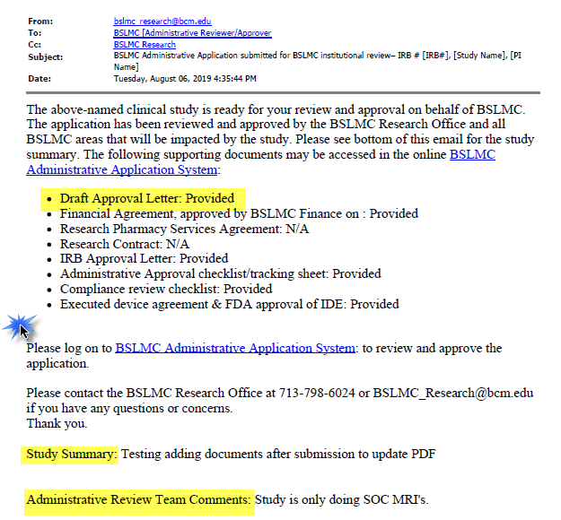

# **Logging into BSLMC Administrative Application**

Log in using your username and password. If you do not have a Baylor ECA, you can submit a request from BCM IT service portal (<https://sso.bcm.edu>) by entering a ticket.

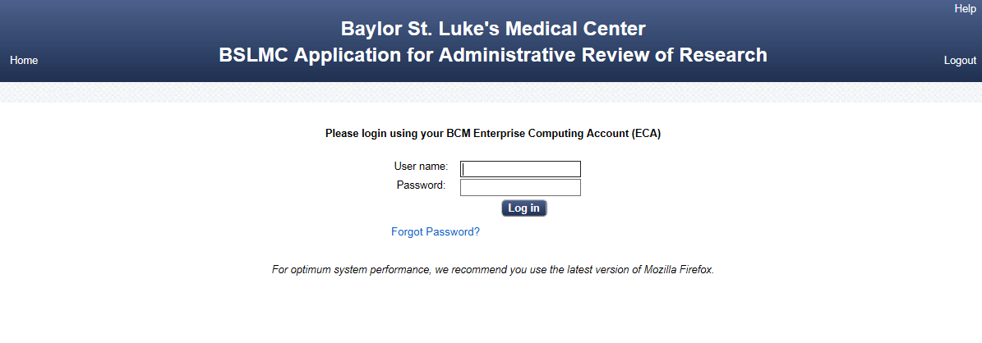

# **Institutional Approver Review, Approval or Deferral**

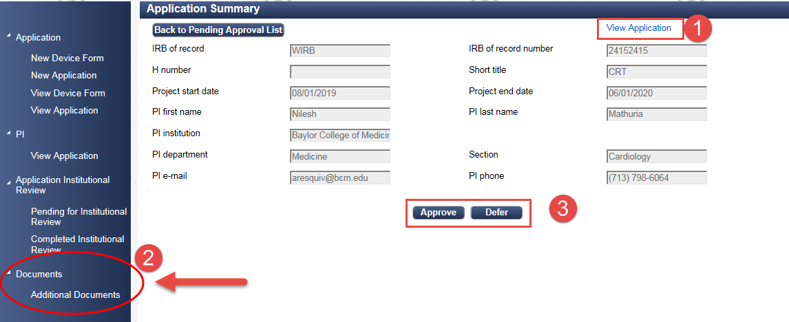

1. Review application
2. Review additional documents.
   1. Print administrative approval letter for signature
   2. Scan and save signed approval letter in Additional Documents
3. Click Approve

If not approved, click Defer and do not sign letter.

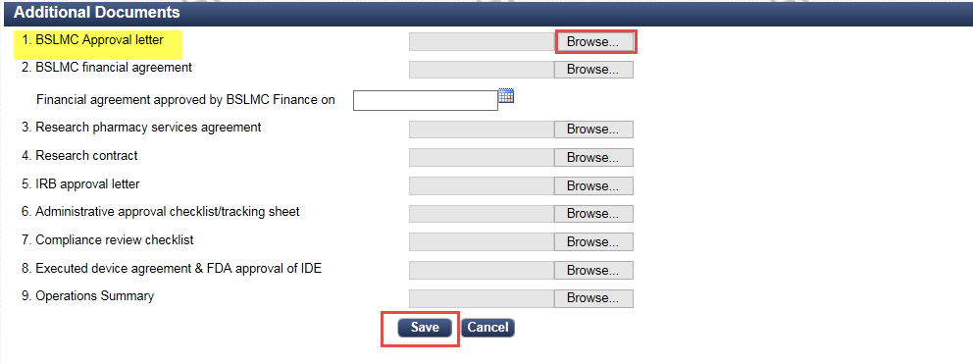

If the study is approved, an email with copy of signed letter and if applicable, financial agreement is sent to the PI and submitter informing them their study was approved. An email is also sent to the administrative review team and department/area reviewer/approver informing them of the approval.

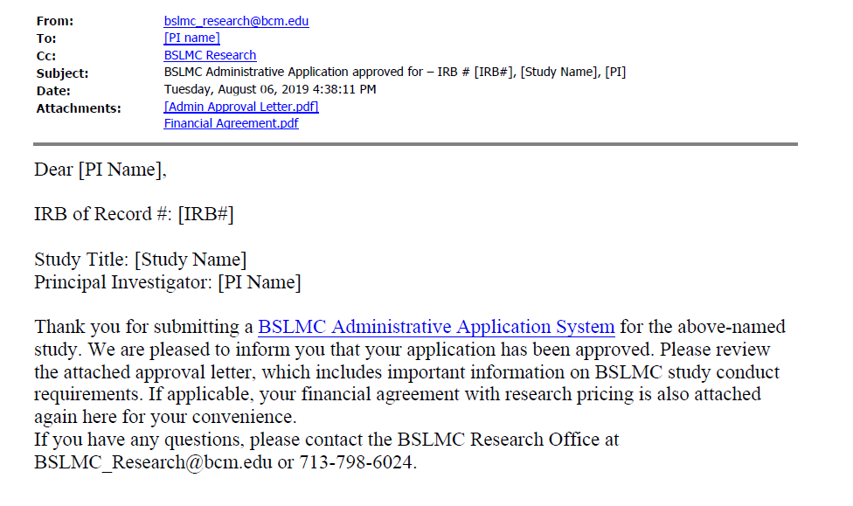

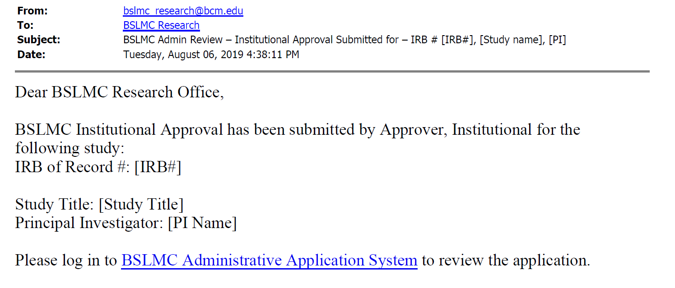

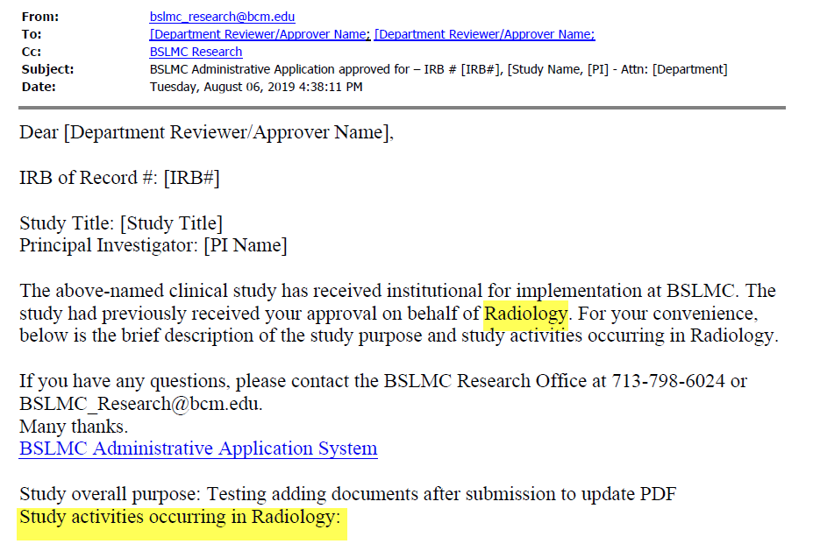

If study is deferred or not approved, then emails are sent to the PI, the department/area reviewer/approver and the administrative review team informing them of the deferral.

